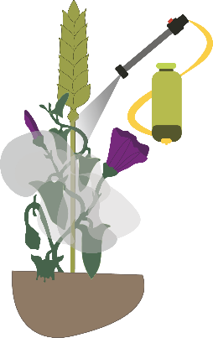
‘Physical and Cultural Weed Control’ and ‘Herbicide Resistance’
EWRS Joint Workshop Pre – Program
Lelystad, The Netherlands
6 - 7 April 2020
Application Form.
Deadline: 28th of February 2020.

Date of Application
First Name
Last Name
Institution
Presentation: | YES | NO
Presentation | ORAL | POSTER
Presentation Title:

Arrival date and time:

Departure date and time

Abstract (300 words)

Note: each attendee has to book her/his hotel room.
Send the application form to:
Marleen.Riemens@Wur.Nl and roland.beffa@bayer.com
Important: EWRS subsidy offer for early career scientists, please contact Prof. Hüsrev Mennan hmennan@omu.edu.tr; or Prof. Josef Soukuk, soukup@af.czu.cz

